TIME SERIES DATA ANALYSIS AND FORECAST METHODS

Lecture 9
Advanced methods of time series forecast and data assimilation

Yekaterinburg
2017
Contents

Lecture purpose 3

Lecture map 3

Part 1. Adaptive forecast concept 4

Part 2. Time series forecast with Singular Spectrum Analysis 5

Part 3. Forecast on the basis of neural networks 10

Part 4. Correction scheme with Data Assimilation technique 16

References 21

Lecture purpose
The purpose of this lecture is to introduce students to models and methods of the adaptive forecast of time series, on a basis of already known approaches to their analysis, and on the basis of modern means of neural network algorithms. Also, students will learn skills and knowledge for correction of multidimensional forecasts on the basis of time series observations, by the means of modern data assimilation methods.

Lecture map

- Advanced methods of time series forecast
- Time series forecast with SSA method based on linear recurrence forms
- Time series forecast with SSA vector method
- Forecast with NAR and NARX neural nets
- Forecast correction with neural nets
- Data Assimilation technique for forecast correction based on new observations
- Ensemble Data Assimilation techniques

Part 1. Adaptive forecast concept
The majority of forecasting methods relies on initial creation of models on the basis of which then there is a forecasting of TS. In this case we need to define at first type of model, to check TS for stationarity, to determine all parameters of a model and to make separation of a data into the deterministic component (which gives us the forecast) and a stochastic component. Only after all these steps it is possible to make the forecast. Benefit of creation of such forecast is the fact that we through model still at the same time see the main properties of the process which generated this row, and with understanding of the hidden dependences the forecast can be made more exact.
But such approach has also a shortcoming – with change of internal dependences of process the model will need to be changed and built again. In this case it is better to apply methods which build the forecast of TS without the need for the deep analysis of the processes which are their cornerstone. We will call such methods of the forecast passing an analysis stage of TS adaptive as they adapt the short-term forecast on accumulation of observations, but not on those parametrical models that could describe accidental processes, the generated this selection of a time series.
It should be noted that any forecast absolutely without stage of process modeling is impossible. But adaptive forecasting methods or hide a stage of implementation of model from the researcher, solving this problem automatically, or process of creation of model is built in the procedure of the forecast.

Part 2. Time series forecast with Singular Spectrum Analysis
In a method of Singular Spectrum Analysis (SSA) to a time series a set of the vectors made of the sliding segments of a number of the selected length of L is put in compliance. These a vector generate trajectory matrixes to which it is possible to tie different linear recurrence relations on the basis of which then and the forecast is under construction.
Consequently, when forecasting the data with SSA method we should find a set of time series, represented by the corresponding linear recurrent formulas (LRF). At the same time the order of LRF can be in advance unknown, but it also is not required if to make only the forecast. The data managed by LRF naturally generates recurrent continuation as each his member is a linear combination of a previous data. Therefore coefficients of this linear formula can be used also for continuation of TS. It is important to note that it is optional to look for LRF of the minimum dimension, as any LRF managing a TS leads to the same continuation, so, the method can be considered adaptive.
The general idea of finding of LRF is as follows. Let d – the minimal dimension of all LRF, corresponding to the data. If the window L is more than d, thus number of observations is rather big, and the dimension of trajectory space equals d. This trajectory space generates LRF of dimension 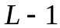, which manages TS. The initial basic SSA method generates basis of trajectory space, and already on its basis managing LRF is under construction. Applying LRF to the last points of a data we will receive its forecast. In the conditions of asymptotic divisibility, continuation will be based on all of components, therefore we do not need to decompose the data with SSA.
The whole separate theory is connected with trajectory vector spaces and linear recurrence formulas generated by them. Here we will not look into it further, and we will only use the results which are already received and proved in this field of science.

Let's describe formally an algorithm of recurrent forecasting.

- Input data for the SSA forecast algorithm are: initial time series 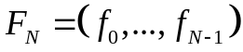 with number of points N, selected window L, number M of predicted observations.
- Let's define some vector space  of dimension 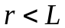. This space is normally set by some orthonormal basis 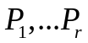, but the results of forecasting do not depend on a specific basis.
- With SSA algorithm we can construct a trajectory matrix 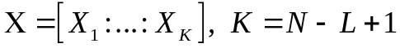.
- Let's find a matrix 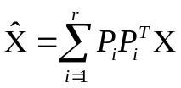, where - orthonormal basis for space . In fact, new trajectory matrix will be an orthogonal projection of X on space .
- As the new matrix 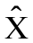 will be a Hankel matrix (or it will be transformed to that), according to the theory of singular spectrum analysis it is a trajectory matrix for some new time series 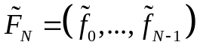.
- Let 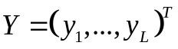 – a vector from the space. In the theory of LRF it is proved that the last coordinate of this vector is a linear combination of its other components:
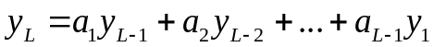 (9.1)
- Denote
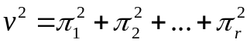 (9.2)
where 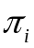 – the last component of basis vector P_{i}.
- Then the number of weight factors 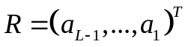 can be found with formula:
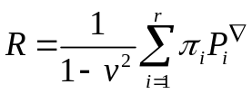 (9.3)
and it does not depend on the initial basis of space .
- With the stated above designations and based on SSA method the forecast is a time series 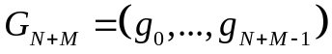, which is recreated with:
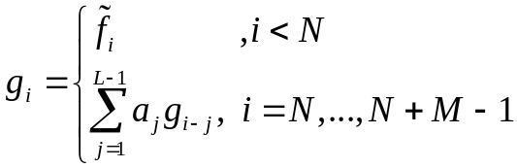 (9.4)
The second line in (9.4) is the needed forecast of observations for TS.

The mentioned technique of the forecast on the basis of the SSA method and use of LRF has the advantages and shortcomings. Benefits of such approach are its strict mathematical description, ample opportunities of a variation of initial parameters and lack of need a slip of optimum grouping a component. But the method has also an essential shortcoming – it is badly formalized in the form of program algorithms. Really, one of input parameters (basis of space) is necessary to define in a random way, but at the same time we should not break its characteristic properties. There are specialized algorithms of creation of similar vectors, but they demand the analysis of those TS, on which the adaptive property will be lost.
With respect thereto, in practice more often instead of the similar strict theoretical description of the forecast on the basis of the SSA method in a combination with LRF, the vector SSA-forecast is used.

The technique of this forecast looks as follows:
- Input data: initial time series with number of points N, selected window L, number M of predicted observations.
- Let's carry out the partial SSA analysis set by TS: only a stage of decomposition and, the most important, we will define grouping terms of the I components (that is we will define numbers of the eigen-triplets). Averaging of the eigen-triplets does not happen (the last step).
- To the 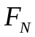 only one random point from known level range is added:
(9.5)
- This data of length N+1 is exposed to SSA decomposition (only steps of decomposition and formation of a trajectory matrix), but without any assessment of the parameters, and based on the estimates from the 2nd step.
- The received eigen-triplets of a new data 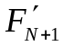 are grouped and averaged on the basis of grouping terms I from the 2nd step of this algorithm. It is important – no new estimations occur.
- As a result of averaging, the new time series will be received 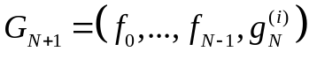, for which the first N points match with initial TS, and the last observation is the pre-forecast. The first iteration of G does not change in comparison with an initial data as neither the trajectory matrix, nor a grouping method, nor other parameters are revised.
- The observation 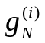 is only an initial approximation of the forecast. For the exact forecast point we estimate the 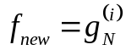 of time series , and then repeat steps from 4 to 6 until the difference between consecutive approximations 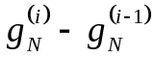 is not close to zero, that is until the value will stop to change with every repeating iteration.
- The resulting observation is accepted as the one-step forecast point. For continuation of the forecast, a new number of length N+1 created for the new time series forecast 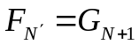, and the technique repeated again, but only from the third step as throughout all algorithm of the forecast there is no need again to look for necessary grouping I of components.
Apparently from the description of this algorithm, it is in many respects equivalent to the forecast on the basis of LRF of spaces. But the similar descriptions implemented in the form of computational programs are simpler.
This prediction algorithm has benefits and shortcomings too. A lack of an adequate choice of grouping terms I. It is not always a simple task, moreover, forecast accuracy most of all depends on the grouping choice a component, than from any other parameters. In practice, for forecasting it is necessary to group as little as possible eigen-triplets, because the more we group them, the more final trajectory matrix will worsen, and the final forecast can “scatter” quicker. Other problem connected with grouping is that if we recover not only the main components (a trend, seasons, cycles), but also noise, then accuracy of the forecast it is not adequate. One more implicit problem of this algorithm is its speed. Steps from 4 to 6 repeated again and again, yet the predicted point might not cease to change. The problem is that some points have very slow convergence. As a result the number of repetitions of these steps can reach huge number without essential increase in accuracy. In this case we usually add restriction to the number of iterations of a cycle for steps 4-6 after which either interrupt the forecast, or take the last found point for the forecast.
Advantages of an algorithm are simplicity of its implementation, high extent of automation and also the fact that for all algorithm of the forecast we determine all parameters of a method (including a method of grouping of eigen-triplets) only once.

Part 3. Forecast on the basis of neural networks
Now artificial neural networks are used for a solution of the wide class of tasks, beginning from pattern recognition and classification to the creation of systems of artificial intelligence. It would be surprising if sooner or later some technique to use the neural networks for the analysis and forecasting of time series has not been created. In this case we, most of all, are interested in a problem of forecasting of TS by means of neural networks, rather than task of their analysis and decomposition. In this area neural networks have essential benefits, mostly because they are adaptive that is such forecasting completely relies only on data and does not demand its preliminary decomposition and the detailed analysis.
The theory of neural networks is studied in the different disciplines, besides there is a huge number of education guidance and materials with description of their complete theory. Therefore, here we will not study in detail their basic structure, the theory of creation, classification, etc., and will engage directly in application of neural networks to a problem of forecasting for time series.
It is known that autoregressive models and any regression models in general are suitable for forecasting of TS as they describe functional dependences of the current values of a data from the previous observations. But in order to create even the simplest AR model it is required to carry out a huge number of work, the most difficult of which is, to define an order (p, d, q) of ARIMA model. For the right forecast we need to evaluate the whole three numerical parameters of model and then also to check it for adequacy.
At the same time neural networks solve many problems which are just designed to replace the person, from the field of classification of objects or from the field of decision making. To some extent it is possible to call a problem of search of an ARIMA order and assessment of its parameters as a “classification and the choice of the ARIMA model”. The theory of application of neural networks for forecasting of TS is based on this idea.
Let the forecast of TS be described in the form of some autoregressive dependence model. At the same time the AR form of an order of p can be nonlinear, that is we do not impose any restrictions on a form of initial TS y and autoregressive binding function f :
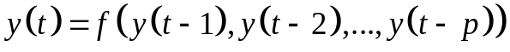 (9.6)
We need to adjust the optimum forecast of function (9.6) to a known TS y with the condition of minimization of a root mean square error of a variance (in the same way as it was for an ARIMA models).
We create standard feed-forward neural network with two layers with sigmoidal function of activation of neurons for the hidden layers and linear function of activation for output layers. At the same time the neural network belongs to the class of learning networks with the teacher. Parameter of this network is the number of neurons of the hidden layer.
The AR forecast model (9.6) on the basis of this neural network will be called Nonlinear Autoregressive = NAR, and a final predictive model – NAR-net.
Now we have on our hands initial TS, the AR function of model (9.6), neural network with the set parameters and the principle by which there has to be a minimization of an error. It is already quite enough for training of our neural net. In that case the forecast algorithm on the basis of NAR-net will look as follows:
- Parameters of NAR network are defined: number of neurons for the hidden layer and order of p for the AR model.
- A part of TS (not less than 70%) is used for a training of neural network by the principle of minimization of a mean square error. Algorithms of training can be different.
- A part of TS is used to check and validate the received model by the principle of retrospective forecasting.
- As a result of neural network training we will receive adaptive coefficients of AR model (9.6).
- The forecast of TS happens similarly to recursive schemes described for forecasting on a basis of AR models (lecture 8), except that coefficients are defined by neural network.
Conditionally the model of NAR network can be presented in the figure 9.1, where the movement of data is specified by green color (a feed-back indicates autoregressive existence), the blue square corresponds to neural network.
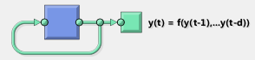
Figure 9.1 – Structure of the NAR-net forecast
The forecast on the basis of NAR network is completely identical to the forecasting on the basis of autoregressive models, except for such key factors as need of manual assessment of parameters of model and a possibility of creation of non-linearity.
Benefits of implementation of NAR network are its simplicity, speed of training and high adaptive property – internal coefficients of a forecast model completely depend on TS and neural network itself.
Such implementation of the forecast on the basis of neural network has also a shortcoming – if initial TS contains noise, with bad signal-to-noise ratio, than a neural network with adaptive forecasting will try to “emulate” noise in the forecast as well.
For a solution of this problem there exist the so-called NARX networks. The recurrent dynamic neural network is called Nonlinear Autoregressive with eXogenous inputs = NARX, if its model is the type of AR(d) model expanded with input x(t):
. (9.7)
By comparing expressions (9.7) to (9.6) it is evident that our forecast model had an extent entry, with which we can influence the final forecast.
What can we use as an input x(t)? Let's remember that distortion of the forecast because of noise in an initial data was a problem of our NAR network. Now we will remember from a lecture 8 the scheme of correction of AR forecasts on the basis of new observations, and it will exactly correspond to expression (9.7) if we equate x(t) – the ARMA model, and y(t) – to the TS, including also the new arriving observations.
For this reason the NARX networks are not a pure forecast models of TS, they are rather a forecast model correction x(t) with observations of TS y(t) on the basis of which this model was created, with the condition of minimization of a mean square error.
Because of this the forecast algorithm on the basis of NARX network will look in a different way:
- For y(t) TS its reduced model without noise x(t) by means of any algorithms of the decomposition/analysis of TS is created (for example, just in the form of a polynomial trend).
- For NARX network its parameters are defined: number of neurons for the hidden layer and order of the AR (d) model (lag).
- The next step is a standard neural network learning process with validation and testing.
- The forecast on the basis of the trained NARX network can be constructed by two methods. The first method is called one-step ahead forecast. That is by means of a reduced model initially predict the single point of 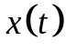 for one step forward, and then the NARX network adjusts it by means of expression (9.7). The corrected forecast of y(t) then is added to initial TS.
- The first method of the forecast demands to increase initial TS every time with one observation. The second method uses another scheme, creating in NARX network a feedback on the y(t) functions (figure 9.2). In this scheme the reduced model assess the forecast of x(t) on the necessary number of points immediately. The NARX network adjusts the points of TS, by using the forecasted points of data. The overall accuracy would be lower, but the speed and independence from new observations are worth it.
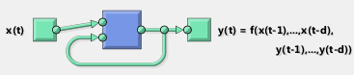
Figure 9.2 – Structure of NARX network with a feedback
Thus, it is possible to draw a conclusion that neural networks are quite applicable, both for forecasting of TS on the basis of NAR networks, and for correction of the forecast on the basis of NARX networks. Benefits are their high universality and adaptive property as they do not demand from any data special characteristics, and also there are huge opportunities of a variation of process of training and creation of neural networks. As the structure of neural networks can significantly change on the course of its creation and training, it gives us a huge opportunity for the finest configuration of accuracy. Shortcomings of neural networks are their high computing costs, necessary for training and validation. Besides, high variability of process for creation of models (9.6) and (9.7) can result in the irreproducible results: two neural networks with identical parameters, but even with very small deviations in the procedure of their training, can give absolutely different forecasts.

Part 4. Correction scheme with Data Assimilation technique
Before we discussed the forecast correction schemes which relied only on models and expressions by means of which this predictive algorithm was constructed. It means that correction scheme is based on the forecast model, not on observations. Nevertheless, there are fields of science in which the predictive model is constructed not from a time series which is a one-dimensional vector of observations, but from a multidimensional process which generates the TS. Then the forecast estimated on this multidimensional model, and its correction has to be evaluated on new observations of the generated time series.
Methods, which deal with the forecast correction of the multidimensional model with its one-dimensional observations, are called methods of Data Assimilation (DA).
In general, by strict definition, methods of the DA family are engaged in establishment of unique correspondence between a multidimensional solution space of some predictive model and a one-dimensional vector of the observations which are available for this system, taking into account errors, arising both in the model and in observations.
From the viewpoint of Data Assimilation approach, initial model must be represented in stochastic dynamic form with two main equations:
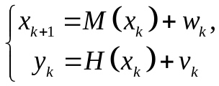 (9.8)
where x_{k} – is the known initial state of model at time point t_{k}; x_{k+1} – state of model at the next time point; M – transition matrix or function, defining the evolution of system with time; w_{k} – noise or error in the model; y_{k} – vector of observational data; H – observation matrix or function, juxtaposing multi-dimensional state of model with one-dimensional vector of observations; v_{k} – observation error. Those two errors w_{k} and v_{k} are supposed to be independent random quantities.
First equation from (9.8) is called forecast equation and second – observation equation. Correspondingly, the whole Data Assimilation algorithm is divided into two steps: the analysis step and the forecast step.
For the analysis step, at time t_{k} we have an initial assumption of model state x_{k}^{f}. It will serve as our background. Starting from this background we reconstruct the corrected model state x_{k}ª (known as analysis), based on the observation data y_{k} at time point t_{k}:
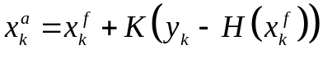, (9.9)
where K – gain matrix or operator, 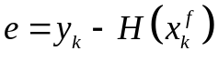 – calculated analysis error between known observation and simulated observation at time point t_{k}.
The analysis stems from the known data – the vector of observations. In this case, in order that constructed analysis would be optimal, the gain K should minimize the analysis error e, taking into consideration all of the other factors. Depending on the approach to minimize this error, there are several Data Assimilation techniques. Within this sequential context, the gain is often called the Kalman gain. Thus, the family of those Data Assimilation methods is often called Kalman filter.
Up to this point, the observations were used to update prior knowledge of the system state (the background). In the forecast step we estimate the next system state at time point t_{k+1} using our knowledge of the system evolution from time t_{k} to time t_{k+1}. Keeping in mind errors from (9.8) and analysis from (9.9), the following estimator can be built:
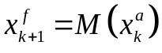 (9.10)

Thus, there will be a correction of the forecast: the model gives us some forecast, generating a time series which is compared to the available selection of observations which is useful to us on the following step of the forecast. The scheme of such correction is represented in the figure 9.3:

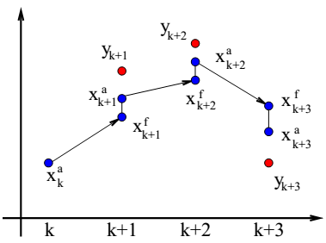
Figure 9.3 – The scheme of Data Assimilation technique

If initial problem is linear and operators M and H from (9.8) can be represented as matrices, than M(x_{k})=M·x_{k} and H(x_{k})=H·x_{k}. Assuming that errors w_{k} and v_{k} are unbiased, uncorrelated in time and their covariance error matrices are Q_{k} and R_{k}, respectively, than the Kalman gain is calculated as:
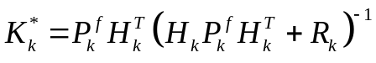 (9.11)
where 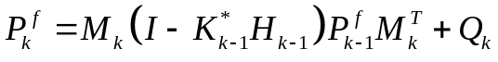 – forecast error covariance matrix.
Notice that these expressions are very similar to the correction of the regression forecast which we studied earlier. There is nothing surprising – both of them are based on the principle of minimization of an error of deviation between real observations and estimated points.
For a linear case of model with matrices M and H, the forecast correction scheme based on DA is simple. Let the initial state of model 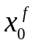 be known and the initial error covariance matrix is also known 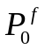. For a step 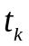 we repeat the following sequence of actions:

- Analysis step. The Kalman gain is calculated from (9.11).
- Correction of a model state is estimated from (9.9).
- The error analysis covariance matrix is estimated as:
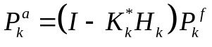 (9.12)
- Forecast correction step. The corrected forecast one-step is estimated with the equation (9.10).
- The new forecast error covariance matrix is established, for the next step:
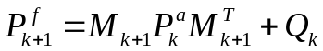 (9.13)

It is important to note that the temporary steps , noted in this algorithm, do not have to match the temporal grid of data. We can correct the forecast with DA not every new observation, but every 5 observations, only at the end of the week, month, not with equal period, etc.
In most cases the simulated model is nonlinear; therefore operators M and H cannot be represented as matrices. Also, the characteristics of errors w_{k} and v_{k} from (9.8) are a priori unknown. In this case we need to use a modified version of Data Assimilation technique – an Ensemble Kalman Filter (EnKF) family of methods. All of those methods have significant distinctions between each other on analysis step. From all family of these techniques which are calculated by dozens we will consider only the most universal, called The Stochastic Ensemble Kalman Filter = SEnKF.
The algorithm of this method looks as follows. For a step we repeat the following sequence of actions
- Draw a statistically consistent observation set:
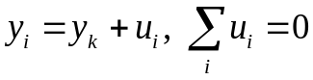 (9.14)
and compute the empirical error covariance matrix
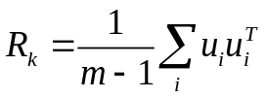. (9.15)
- Compute the gain with eq. (9.11), where instead of matrix product we calculate the following estimations:
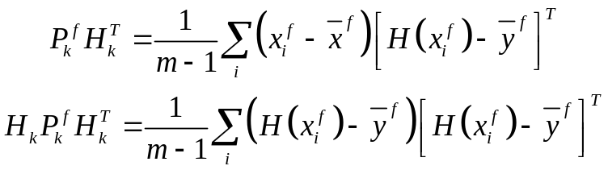 (9.16)
where 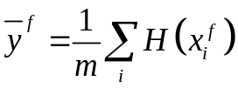.
- According to (9.9) compute the ensemble of analyses x_{i}ª.
- Compute the ensemble forecast for each x_{i}ª with eq. (9.10) and their mean forecast value
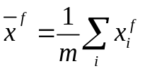. (9.17)
- Compute the forecast error covariance matrix, needed for the next step:
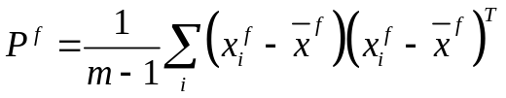 (9.18)
Thus it is possible to increase the forecast accuracy with Data Assimilation with every new gained observation, even in case of multidimensional model of system evolution, which generated the time series.

References

1. Golyandina N., A. Zhigljavsky. Singular Spectrum Analysis for time series. — Springer Briefs in Statistics. — Springer. — 2013. — 120 p. ISBN 978-3-642-34912-6.
2. MathWorks Center. NARX Network. Design Time Series NARX Feedback Neural Networks. https://www.mathworks.com/help/nnet/ug/design-time-series-narx-feedback-neural-networks.html
3. Marc Bocquet. Introduction to the principles and methods of data assimilation in geosciences. Lecture notes. — Ecole des Ponts ParisTech. — 2015. — 88 p.
4. G. Evensen. The ensemble kalman filter: theoretical formulation and practical implementation. Ocean Dynamics. — 2003. — vol. 53, pp. 343–367

